Meiosis Name:_______________
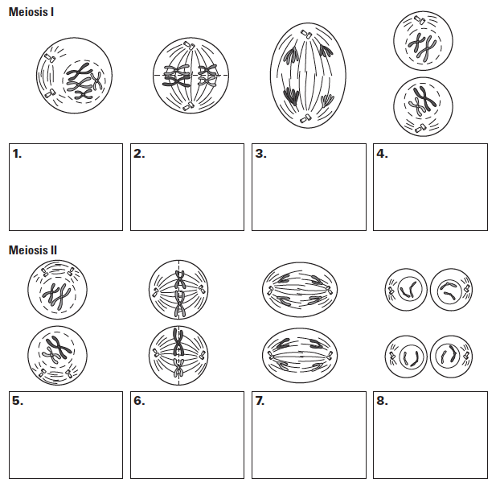
In each of the boxes below describe what is happening in the pictures then answer the questions below.

- What type of cells does meiosis produe?

- Are the products of meiosis haploid or diploid?

- How does meiosis ensure they end up haploid instead of diploid?

- Why do they need to be haploid?

- Are each of the 4 cells produced by meiosis genetically identical?

